Philippine Copyright 2026
by the Author
and the
Polytechnic University of the Philippines
Unisan, Quezon Campus

All rights reserved. Portions of this study may be reproduced in any form with a proper acknowledgement of the author.

DEVELOPMENT OF SOIL MONITORING AND CLASSIFICATION USING IOT WITH FERTILIZER RECOMMENDER SYSTEM FOR

RICE FARMERS IN UNISAN, QUEZON]

A Capstone Project Proposal
Presented to the Faculty of the
Polytechnic University of the Philippines
Unisan, Quezon Campus

In Partial Fulfilment of the Requirements for the Degree
Bachelor of Science in Information Technology

by

Benjamin G. De Mesa Jr.
Raven Chase F. Gliane
Darrel Shen S. Gono
Renz Aron P. Taguiam
John Matthew E. Zulueta

October 2026

CERTIFICATION OF ORIGINALITY
This capstone project “DEVELOPMENT OF SOIL MONITORING AND CLASSIFICATION USING IOT WITH FERTILIZER RECOMMENDER SYSTEM FOR RICE FARMER IN UNISAN, QUEZON”, prepared and submitted by BENJAMIN G. DE MESA JR., RAVEN CHASE F. GLIANE, DARREL SHEN S. GONO, RENZ ARON P. TAGUIAM, JOHN MATTHEW E. ZULUETA, in partial fulfillment of the requirements for the degree, BACHELOR OF SCIENCE IN INFORMATION TECHNOLOGY has been examined and recommended for Oral Examination.

Evaluation Committee

JHUNEL B. PEÑAFLORIDA
Adviser

RYAN P. VILLALON, MIT ANGELO P. PERA, MSIT
Member Member

JONATHAN A. MARQUEZ, DEM
Member

APPROVAL
Approved by the Panel on Oral Examination on _________, with the grade of _________.

JONATHAN A. MARQUEZ, DEM
Chair

RYAN P. VILLALON, MIT ANGELO P. PERA, MSIT
Member Member

Accepted in partial fulfillment of the requirements for the degree
Bachelor of Science in Information Technology.

EDWIN G. MALABUYOC, DPA
Director

Date of Passing the Comprehensive Examinations: __________________ (If applicable)

ACKNOWLEDGMENTS
This section recognizes persons and organizations who/which assisted the proponents in the completion of the thesis. Acknowledgements should be expressed simply and tactfully.

CERTIFICATION OF ORIGINALITY
This is to certify that the research work presented in this capstone project, DEVELOPMENT OF SOIL MONITORING AND CLASSIFICATION USING IOT WITH FERTILIZER RECOMMENDER SYSTEM FOR RICE FARMERS IN UNISAN, QUEZON for the degree Bachelor of Science in Information Technology at the Polytechnic University of the Philippines embodies the result of original and scholarly work carried out by the undersigned. This capstone project does not contain words or ideas taken from published sources or written works that have been accepted as basis for the award of a degree from any other higher education institution, except where proper referencing and acknowledgment were made.

BENJAMIN G. DE MESA JR.
Researcher

RAVEN CHASE F. GLIANE
Researcher

DARREL SHEN S. GONO
Researcher

RENZ ARON P. TAGUIAM
Researcher

JOHN MATTHEW ZULUETA
Researcher

______________________________
Date Signed (date, month, year)

ABSTRACT
Title | : | The Development of Soil Monitoring and Classification using IoT with Fertilizer Recommender System for Rice Farmers in Unisan, Quezon
Researchers | : | Benjamin G. De Mesa Jr.  Raven Chase F. Gliane  Darrel Shen S. Gono  Renz Aron P. Taguiam  John Matthew E. Zulueta
Degree | : | Bachelor of Science in Information Technology
Institution | : | Polytechnic University of the Philippines – Unisan, Quezon Campus
Year | : | 2025
Adviser | : | Jhunel B. Peñaflorida

(Note: The Abstract is a brief description summary of the thesis, capstone or dissertation. It contains the main objective of the study, a brief description of the research method, major findings, conclusions or main arguments, and recommendations. Abstract should be doubled – spaced, and not more than 250 words.)
This capstone project develops a Soil Monitoring and Classification System using IoT for rice farmers in Unisan, Quezon, to replace inefficient manual estimation. The system automates nutrient analysis and fertilizer advice, improving data accuracy and productivity. Developed using the Iterative SDLC model, it integrates hardware sensors with machine learning to meet specific farming needs. Key features include real-time monitoring and a web-based recommender dashboard. Evaluated against ISO 25010 standards, the implementation is expected to reduce fertilizer costs and optimize crop yields, significantly enhancing sustainable farming practices in the community.

Keywords: Polytechnic University of the Philippines, Bachelor of Science in Information Technology, (Soil Monitoring, Internet of Things (IoT), Fertilizer Recommender System, Machine Learning, Precision Agriculture)

TABLE OF CONTENTS
 |  | Page
Title Page |  | i
Certification and Approval Sheet |  | ii
Acknowledgments |  | iii
Certification of Originality |  | iv
Abstract |  | v
Table of Contents |  | vi
List of Tables |  | vii
List of Figures |  | viii
1 | The Problem and Its Setting
 | Introduction | 1
 | Theoretical Framework | 8
 | Conceptual Framework | 12
 | Statement of the Problem | 13
 | Scope and Limitations of the Study | 14
 | Significance of the Study | 16
 | Definition of Terms | 17
2 | Review of Literature and Studies
 | Challenges in Traditional Soil Monitoring and Fertilizer Application | 19
 | IoT-Based Soil Monitoring and Sensor Technologies | 20
 | Machine Learning Algorithms for Fertilizer Recommendation | 21
 | System Evaluation Based on ISO 25010 Standards | 22
 | Synthesis of the Reviewed Literature and Studies | 23
3 | Methodology
 | Research Design | 25
 | Research Locale | 27
 | Sources of Data | 28
 | Research Instrument | 30
 | Data Gathering Procedure | 32
 | Statistical Data Analysis | 34
 | Ethical Considerations | 36
 | Software Requirement Specification | 37
 | Software Development Life Cycle | 38
 | System Flow Diagram | 39
 | Data Flow Diagram | 40
 | Software Prototype | 41
 | Project Implementation Plan | 42
4 | Results and Discussion
 | Challenges Faced by ABC Company on handling Information Manually | 38
 | System Evaluation of the Proposed Web – based Information Management System | 40
 | Feature analysis of Web – based Information Management System | 41
 | Feature analysis of Web – based Information Management System | 43
5 | Summary of Findings, Conclusions, and Recommendations
 | Summary of Findings | 42
 | Conclusions | 44
 | Recommendations | 46
References |  | 48
Appendices
 | Appendix 1: Permit to Conduct Study | 50
 | Appendix 2: Instruments | 52
 | Appendix 3: Certificate of Originality | 54
 | Appendix 4: Certificate of Editing | 56
 | Appendix 5: Acceptance Letter of Adviser | 57
 | Appendix 6: User Manual | 58
 | Appendix 7: Biographical Statement | 60

LIST OF TABLES
Number | Title | Page
1 | Weighted Mean Interpretation Table | 7
2 | Table Caption | 10
3 | Table Caption | 12
4 | Table Caption | 13
5 | Table Caption | 14
6 | Table Caption | 15
7 | Table Caption | 17
8 | Table Caption | 18
9 | Table Caption | 20
10 | Table Caption | 22

LIST OF FIGURES
Number | Title | Page
1 | Illustration of the framework for Soil Monitoring and Classification using IoT with Fertilizer Recommender System. | 7
2 | Waterfall SDLC Model | 10
3 | Proposed System Architecture | 12
4 | Conceptual Framework of the Proposed System | 17
5 | Waterfall SDLC Model | 20
6 | Proposed System Architecture | 22
7 | Conceptual Framework of the Proposed System | 27
8 | Waterfall SDLC Model | 30
9 | Proposed System Architecture | 32
10 | Conceptual Framework of the Proposed System | 37
11 | Waterfall SDLC Model | 40
12 | Proposed System Architecture | 42
13 | Conceptual Framework of the Proposed System | 47
14 | Waterfall SDLC Model | 48
15 | Proposed System Architecture | 52
16 | Conceptual Framework of the Proposed System | 57
17 | Waterfall SDLC Model | 60
18 | Proposed System Architecture | 62
19 | Conceptual Framework of the Proposed System | 57
20 | Waterfall SDLC Model | 60
21 | Proposed System Architecture | 62

Chapter 1
THE PROBLEM AND ITS SETTING
Introduction
Agriculture is a vital sector that sustains food production, supports livelihoods, and drives economic growth. However, the industry is undergoing a significant transformation driven by the integration of Information Technology, specifically the Internet of Things (IoT) and data analytics. This shift, often referred to as "Precision Agriculture," moves farming away from manual estimation toward data-driven decision-making to optimize resources. Within this framework, monitoring soil fertility is paramount, as elements such as nitrogen, phosphorus, potassium, pH, temperature, and moisture play a crucial role in determining productivity (Hossain et al., 2024). To manage these complex variables, modern technologies combine IoT sensors for real-time data collection with machine learning algorithms that identify patterns and classify soil types according to their characteristics. This accurate classification enables the determination of suitable fertilizers and crops, promoting sustainable resource use. Reinforcing this technological approach, (Kethineni et al., 2024) demonstrated that such web-based platforms empower farmers to make informed decisions, significantly improving both yield and profitability.
However, reliance on traditional soil management remains prevalent, given that conventional soil testing is costly and typically requires weeks to generate results, many farmers miss the optimal window for applying soil treatments (Louiella Samaniego & Gallego, 2024). Consequently, this delay forces farmers to resort to estimation; this “blind” application frequently leads to excessive chemical input, which accelerates soil acidification and contaminates nearby water sources (Vu Ngoc & Giang Trung, 2025). Furthermore, data availability alone is insufficient, as many smallholder farmers struggle to interpret technical nutrient reports, leaving them uncertain about the appropriate fertilizer strategy to implement (Goloran, 2025). In the Philippine context, (Kai et al., 2025) observed that organic farms in Sariaya, Quezon, and Los Baños, Laguna continue to experience low soil fertility due to limited nutrient availability and weak microbial activity, particularly when transitioning from chemical to organic farming. These challenges underscore the critical need for accessible, data-driven tools that empower farmers to understand their soil conditions and enhance agricultural productivity.
Therefore, this study proposes the Development of Soil Monitoring and Classification using IoT with Fertilizer Recommender System for Rice Farmers in Unisan, Quezon. The main goal is to modernize local rice farming by replacing manual guesswork with precise, data-driven technology. Specifically, the project aims to build an IoT device that collects real-time data on soil nutrients (Nitrogen, Phosphorus, Potassium), pH levels, and moisture. This data is then analyzed using Machine Learning to accurately determine the soil's health and identify what nutrients are missing. Finally, the system provides an easy-to-use web dashboard that automatically recommends the right fertilizer, helping rice farmers and the Municipal Agriculture Office (MAO) save money, improve crops, and protect the soil.
By improving soil understanding, preventing fertilizer misuse, and increasing crop productivity, this project contributes to sustainable agricultural practices aligned with the United Nations Sustainable Development Goals (SDGs), particularly Goal 2 (Zero Hunger) and Goal 12 (Responsible Consumption and Production). Moreover, it supports the University Research Agenda by promoting technological innovations that enhance community development and environmental conservation.

Theoretical Framework
The theoretical foundation of this study is anchored on the Precision Agriculture Theory by (Robert, 2002), which focuses on using technology to collect and analyze agricultural data for better decision making and resource management.
This theory highlights that accurate information about soil conditions, such as pH, NPK, and moisture levels, allows farmers to apply the right type and amount of fertilizer to improve yield and reduce waste.
In the context of this research, the application of Precision Agriculture Theory is defined by two primary variables: Spatial Variability and Site-Specific Management (SSM). Spatial Variability refers to the quantitative differences in soil characteristics across different areas of the farm. In this system, this variable is operationalized through the specific soil parameters such as Nitrogen, Phosphorus, Potassium (NPK), pH, and moisture which are detected by the IoT sensors. Site Specific Management, on the other hand, represents the decision-making variable. It is the process of matching resource application to the specific needs of the soil. In this study, SSM is facilitated by the Fertilizer Recommender System, which translates the collected data into precise input instructions, ensuring that fertilizers are applied only where and when they are needed to optimize growth.
Guided by this idea, the study developed a soil monitoring and classification system using IoT technology with a fertilizer recommender feature. The system aims to help farmers and the Municipal Agriculture Office (MAO) of Unisan, Quezon monitor soil health and make data-driven decisions that lead to sustainable farming practices. Using sensors and web-based analytics, the system provides real-time updates that support efficient fertilizer management and environmental protection, which are essential goals of modern precision agriculture.
This theory supports the Technology Acceptance Model (TAM) by (Davis, 1989), which explains how people decide to accept and use new technology. It focuses on two important factors, perceived usefulness and perceived ease of use.
In this study, Perceived Usefulness is defined as the extent to which farmers and agricultural officers believe that the Soil Monitoring System will improve their operational efficiency and crop productivity. If the system effectively detects nutrient deficiencies and provides accurate recommendations, users will perceive it as a valuable tool. On the other hand, Perceived Ease of Use refers to how effortless the system is to operate. Given that some farmers may have limited technical skills, the hardware and web dashboard must be designed with a simple and intuitive interface to ensure that the technology is accessible and not burdensome to the user.
The integration of these two theories creates a holistic framework that ensures both technical accuracy and user adoption. While the Precision Agriculture Theory guides the technical development of the system to ensure it captures precise data for site specific management, the Technology Acceptance Model ensures that this complex technology is designed in a way that is approachable for the end users. By balancing the scientific rigor of soil analysis with the practical requirements of user experience, the study guarantees that the proposed solution is not only functionally capable of improving soil health but also socially acceptable to the farming community in Unisan, Quezon.
In the context of this study, these factors determine how farmers and MAO staff will adopt and continue to use the soil monitoring and fertilizer recommender system. When the users find the system easy to operate and helpful in improving soil management, they are more likely to use it regularly. The combination of the Precision Agriculture Theory and TAM shows that the success of the proposed system depends not only on the accuracy of the technology but also on how users accept and utilize it to improve agricultural productivity.
Conceptual Framework
The Development of Soil Monitoring and Classification using IoT with Fertilizer Recommender System is guided by a conceptual framework composed of the input, process, and output. This framework illustrates how the system is designed, developed, and implemented to help farmers and the Municipal Agriculture Office (MAO) of Unisan, Quezon monitor soil conditions and receive accurate fertilizer recommendations.
Figure 1. Illustration of the framework for Soil Monitoring and Classification using IoT with Fertilizer Recommender System.
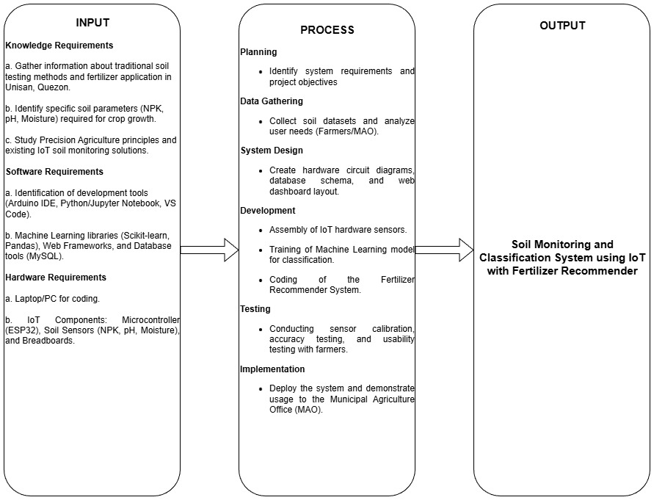
The study follows the Input–Process–Output (IPO) model, illustrating how resources and data are transformed into a fully functional Soil Monitoring and Classification System using IoT with Fertilizer Recommender.
The Input includes the knowledge, software, and hardware requirements necessary for the development of the system. Knowledge requirements involve gathering information about traditional soil testing methods in Unisan, identifying the specific soil parameters needed for crops, and studying Precision Agriculture principles. Software requirements consist of the tools and technologies such as Arduino IDE, Python, and Web Frameworks, including machine learning libraries for data analysis. Hardware requirements include laptops/PCs for development and the specific IoT components like microcontrollers and soil sensors.
The Process involves several phases: planning, data gathering, system design, development, testing, and implementation. Planning identifies the objectives and requirements of the project; data gathering involves collecting necessary soil datasets; system design focuses on creating the hardware schematics and user interface; development builds the IoT device and trains the machine learning model; testing ensures sensor accuracy and system usability; and implementation involves deploying the system to the end-users.
The Output of the study is the Soil Monitoring and Classification System using IoT with Fertilizer Recommender, an integrated platform designed to automate soil analysis and provide precise fertilizer advice to improve agricultural productivity."

Statement of the Problem
In the Municipality of Unisan, Quezon, the agricultural sector faces significant challenges regarding soil management and fertilizer application. Despite the availability of modern farming techniques, many smallholder farmers in the area continue to rely on traditional, manual methods. A primary observation is the prevalence of estimation-based fertilization, where farmers apply nutrients based on intuition or habit rather than actual soil needs. This practice often leads to either the under-application of essential nutrients, resulting in poor crop growth, or over-application, which causes unnecessary financial expense and contributes to soil acidity.
Furthermore, access to precise soil analysis remains a major hurdle for the community. The lack of accessible, low-cost testing facilities means that farmers cannot easily verify the NPK (Nitrogen, Phosphorus, Potassium) and pH levels of their land before planting. Consequently, both the farmers and the Municipal Agriculture Office (MAO) lack the real-time data necessary to make informed decisions. This information gap hampers the ability to implement precision agriculture, keeping local crop yields below their potential and making it difficult to transition to more sustainable, data-driven farming practices.
General Objectives.
The primary objective of this study is to design, develop, implement and evaluate a "Soil Monitoring and Classification System using IoT with Fertilizer Recommender System" that aims to provide an integrated, web-based platform that allows farmers and agricultural officers in Unisan to monitor real-time soil health and receive automated, accurate fertilizer recommendations to optimize crop productivity.
Specific Objectives.
This study aims to:
- To identify the challenges encountered by farmers in Unisan, Quezon, regarding traditional soil monitoring and fertilizer application.
- To design, develop, and implement an IoT-based hardware device that accurately collects real-time soil data, specifically Nitrogen (N), Phosphorus (P), Potassium (K), pH levels, and moisture content.
- To integrate a machine learning model that analyzes sensor data to classify soil conditions and generate optimal fertilizer recommendations.
- To evaluate the system in terms of accuracy, usability, and operational efficiency using ISO 25010 software quality standards.
Research Questions.
- What are the operational challenges encountered by farmers and the Municipal Agriculture Office (MAO) in Unisan, Quezon regarding the current manual methods of soil monitoring and fertilizer application?
- How will the Soil Monitoring and Classification System using IoT with Fertilizer Recommender be developed in terms of the hardware architecture for real-time sensor data collection, the utilization of machine learning algorithms for accurate soil classification, and the design of a web-based dashboard for user interaction?
- What is the architectural design of the machine learning model used to analyze sensor data and classify soil conditions?
- What is the level of software quality of the developed system as evaluated by IT experts and end-users based on ISO 25010 Software Quality Standards, specifically in terms of functional suitability, performance efficiency, interaction capability, and reliability?

Scope and Limitations of the Study
The scope of this study is the Development of Soil Monitoring and Classification using IoT with Fertilizer Recommender System.
The scope of this study focuses on the development of a Soil Monitoring and Classification System using IoT with a Fertilizer Recommender. Conceptually, the research investigates key soil-fertility variables, specifically Nitrogen (N), Phosphorus (P), Potassium (K), soil pH, and moisture levels, examining the application of machine learning for soil classification and the generation of data-driven fertilizer recommendations. In terms of population, the target users are the farmers and the Municipal Agriculture Office (MAO) within the geographic boundary of Unisan, Quezon. Methodologically, the study utilizes a developmental research approach, involving the creation of a web-based system integrated with IoT sensors where data is collected and analyzed using a machine learning model. The system's effectiveness will be evaluated based on its accuracy, usability, and affordability, with the development, implementation, and data-gathering phases conducted within the academic year 2025-2026.
To maintain a manageable and focused investigation, the study is delimited by specific intentional choices. Conceptually, the fertilizer recommendation model is strictly delimited to the soil parameters (NPK, pH, moisture) measured by the sensors; it does not investigate or incorporate external variables such as specific plant diseases, pest infestations, or dynamic weather patterns, which are acknowledged as significant but remain beyond the conceptual boundary of this project. Methodologically, the research focuses on the development and integration of the software system, specifically the web platform and machine learning model, and does not include the design or manufacturing of the IoT sensor hardware itself. Furthermore, the study is geographically delimited to participants from Unisan, Quezon; therefore, the findings and the specific machine learning model may not be directly generalizable to other municipalities with different soil types and agricultural contexts.

Significance of the Study
This research is significant as it addresses critical gaps in local agriculture through technological innovation.
This study offers significant contributions to both the academic field and the local agricultural sector. Theoretically, it contributes to the existing body of knowledge by demonstrating a practical application of IoT and machine learning specifically within the context of Philippine agriculture, extending precision agriculture models to be adaptable for smallholder farmers. Practically, the research produces a functional, data-driven tool that serves as a tangible solution moving beyond traditional, estimation-based farming. By enabling farmers to apply precise amounts of fertilizer, the system is expected to reduce operational costs and minimize fertilizer misuse, thereby promoting more efficient agricultural practices.
For Municipal Agriculture Office (MAO). The office will gain a centralized data-monitoring platform to provide more effective, evidence-based agricultural support to the community. By having access to real-time soil data across the municipality, the MAO can formulate better fertilization guidelines, track soil health trends in Unisan, and implement more targeted interventions for local farmers.
For Farmers. The farmers will be empowered with accurate, real-time soil data and automated fertilizer recommendations, leading to improved crop yields and profitability. This system reduces their reliance on manual estimation, allowing them to apply the precise amount of nutrients needed, thereby minimizing fertilizer costs and preventing soil degradation.
For Researchers. The proponents of this study will benefit by applying their theoretical knowledge of Internet of Things (IoT) and Machine Learning in a real-world agricultural context. This project serves as a practical implementation of their technical skills in hardware integration and software development, enhancing their capability to solve community problems through technology.
For Future Researchers. This study will serve as a valuable reference for future scholars and developers who wish to explore precision agriculture. The system architecture and findings provided in this research can be used as a baseline for further improvements, such as integrating additional sensors, pest detection features, or automated irrigation systems.
By promoting resource efficiency and sustainable practices, this research directly supports the United Nations Sustainable Development Goals (SDGs), particularly Goal 2 (Zero Hunger) and Goal 12 (Responsible Consumption and Production). Furthermore, the environment will benefit from reduced soil degradation and water pollution, which are often caused by fertilizer over-application.

Definition of Terms
For the purposes of this study, the following terms are defined:
Accuracy (System Evaluation). This refers to the degree to which a system’s results match real or expected values. In this study, it measures how correctly the system classifies soil and generates recommendations.
Data Analytics. This refers to techniques used to examine data and support decision-making. In this study, it is used to interpret soil data and generate fertilizer recommendations.
Fertilizer Recommender System. This analyzes soil conditions to recommend the proper type and amount of fertilizer. In this study, it uses soil data such as NPK, pH, and moisture levels to provide tailored fertilizer suggestions.
Internet of Things (IoT). This refers to a network of interconnected devices that use sensors to automatically collect and transmit data to other systems. In this study, IoT enables farmers to monitor soil conditions and make informed decisions about fertilizer use.
Machine Learning. This is a method where a computer analyzes data to make predictions or classifications. In this study, machine learning is used to classify soil conditions based on sensor data.
Municipal Agriculture Office (MAO). This refers to the municipal agency that supports farmers and oversees agricultural initiatives. In this study, the MAO is one of the primary users of the system.
Nitrogen (N). This is an essential nutrient that supports plant growth and leaf development. In this study, nitrogen is measured as part of the soil’s NPK values to assess soil fertility and guide accurate fertilizer recommendations.
Phosphorus (P). This refers to an essential soil nutrient that helps plants develop strong roots and improves flowering and fruiting. In this study, phosphorus is measured as part of the soil’s NPK values to assess soil fertility and guide accurate fertilizer recommendations.
Potassium (K). This is a primary plant nutrient that helps regulate water balance and strengthens plant resistance to stress. In this study, potassium is measured as part of the soil’s NPK values to assess soil fertility and guide accurate fertilizer recommendations.
Precision Agriculture. This uses data and sensors to improve farming efficiency and crop productivity. In this study, it guides the development of a system that promotes sustainable and data-driven farming.
Real-Time Monitoring. This involves tracking information instantly to respond quickly. In this study, it allows farmers to view soil conditions as they change.
Sensor Data. This is the digital output gathered from sensors that measure physical conditions. In this study, it includes NPK levels, pH, moisture, and temperature readings.
Soil Classification. This refers to the process of grouping soil based on its physical and chemical properties. In this study, soil classification is performed using machine learning to analyze soil parameters such as NPK levels, pH, and moisture, allowing the system to determine soil conditions and recommend appropriate fertilizers.
Soil Moisture. This is the measure of how much water the soil holds, affecting plant growth and nutrient absorption. In this study, soil moisture data helps determine the soil’s condition and suitability for fertilizer application.
Soil Monitoring. This refers to the process of measuring and observing the condition of soil over time. In this study, it involves tracking key soil parameters such as nitrogen, phosphorus, potassium (NPK), pH, and moisture levels to assess soil health and support accurate fertilizer recommendations.
Soil pH. This is the level of acidity or alkalinity in soil, which affects nutrient availability for plants. In this study, soil pH is monitored to help determine soil health and appropriate fertilizer application.
Sustainable Development Goals (SDGs). These refer to international targets aiming to end poverty, protect the planet, and ensure prosperity. In this study, the system supports SDG 2 (Zero Hunger) and SDG 12 (Responsible Consumption and Production).
Technology Acceptance Model (TAM). This evaluates user acceptance of technology by analyzing perceived usefulness and perceived ease of use. In this study, TAM helps assess how farmers and MAO staff adopt the system.
Usability (System Evaluation). This refers to how easy and efficient a system is to use. In this study, it evaluates how farmers and MAO staff interact with the platform.
Web-Based System. This is a software application accessed through a web browser. In this study, it delivers soil data, analysis results, and fertilizer recommendations online
Chapter 2
REVIEW OF LITERATURE AND STUDIES
This chapter reviews literature and studies relevant to the development of the Soil Monitoring and Classification System using IoT with Fertilizer Recommender System for Rice Farmers in Unisan, Quezon. It is organized into four major themes: Challenges in Traditional Soil Monitoring and Fertilizer Application, IoT Innovations in Precision Agriculture, Machine Learning Models for Soil Classification, and ISO 25010 Standards for System Evaluation. The synthesis aims to identify patterns, recurring findings, and existing research gaps that establish the theoretical foundation and practical necessity for the proposed system.

Challenges in Traditional Soil Monitoring and Fertilizer Application
This section reviews studies on agricultural operational processes, focusing on the barriers to soil testing and the environmental and economic impacts of manual fertilization methods.
According to Louiella Samaniego & Gallego, 2024, an investigation of soil management practices in the CALABARZON region found a significant hesitancy among small-scale farmers to adopt soil testing. Their study revealed that the primary barriers are the high financial cost and the lack of accessible technology. Farmers often view traditional laboratory testing as impractical due to the long turnaround time, which does not align with the immediate decision-making required during the planting season. Consequently, this forces them to rely on intuition rather than data, leading to suboptimal nutrient management.
Similarly, Vu Ngoc & Giang Trung, 2025 statistically analyzed the consequences of this "blind" application. Their research demonstrated that estimation-based fertilization frequently leads to the over-application of nitrogen and phosphorus. This practice not only inflates production costs but also accelerates soil acidification and contributes to water pollution through nutrient runoff. The study argues that without precise monitoring tools, farmers unknowingly degrade the long-term fertility of their land while attempting to boost short-term yields.
Further, Nakao et al., 2021 confirmed this long-term degradation in a longitudinal study of Philippine paddy soils. Comparing soil samples from the 1960s to the 2010s, they discovered a significant imbalance: while phosphorus levels had increased due to chemical fertilization, potassium levels had critically declined. This "mining effect" suggests that manual estimation fails to account for the complex nutrient uptake of rice crops, resulting in invisible but severe nutrient deficiencies that limit crop potential.
Additionally, G. Vergara et al., 2024 identified that economic constraints further exacerbate these challenges, noting that financial instability often dictates fertilizer application rather than soil needs. Their study on agribusiness challenges found that farmers often delay or reduce fertilizer application based on their available cash flow or credit, rather than the crop's biological requirements. This disconnect between economic capacity and agronomic necessity is identified as a key operational failure of the traditional system.
Moreover, Mishra et al., 2024 emphasized that traditional methods fail to monitor soil biological health. Their comparative analysis of farming scenarios showed that continuous chemical inputs without monitoring degrade soil microbial biomass, which is essential for nutrient cycling. They concluded that sustainable intensification is impossible without transitioning from manual estimation to data-driven soil health monitoring.
Overall, the reviewed studies show that many farmers continue to rely on manual estimation and intuition due to the high cost and impracticality of traditional laboratory testing, which leads to nutrient imbalances, soil degradation, and economic inefficiency. While the negative impacts of "blind" fertilization are well-documented, there is still a gap, as most existing solutions are not tailored to the financial and operational realities of small-scale rice farmers in the Philippines. This underscores the urgent need for an affordable, localized IoT-based system that bridges the disconnect between agronomic requirements and farmers' economic.

IoT-Based Soil Monitoring and Sensor Technologies
This section reviews studies on the technical components required for effective soil monitoring, focusing on sensor accuracy, data transmission protocols, and system integration strategies. It highlights the shift towards real-time data collection technologies that ensure reliability in agricultural environments.
According to Adhikary et al., 2024, the use of NPK sensors based on Time Domain Reflectometry (TDR) is validated for real-time monitoring. Unlike traditional chemical analysis, TDR sensors measure the soil's dielectric constant to infer nutrient content instantly. Their study confirmed that these sensors are sufficiently accurate for precision agriculture and offer the durability needed for field deployment, making them a viable replacement for laboratory testing.
In terms of data transmission, Hartono et al., 2024 demonstrated the superiority of the MQTT (Message Queuing Telemetry Transport) protocol over HTTP for soil monitoring systems. Their implementation showed that MQTT consumes significantly less power and bandwidth, which is critical for rural areas in the Philippines where cellular signals may be unstable. Their design successfully transmitted N, P, K, and pH data from remote fields to a cloud dashboard with minimal latency.
Similarly, Sulaeman et al., 2024 developed and tested a portable soil nutrient detector specifically for irrigated and rainfed paddy soils. Their research highlighted the importance of integrating multiple parameters—N, P, K, pH, and electrical conductivity—into a single probe. Field tests in Java, Indonesia, proved that such portable IoT devices could provide readings comparable to standard laboratory results, offering a practical solution for on-site decision-making.
The integration of these components into a robust system was further explored by Wacas, 2023 in the development of a smart greenhouse system. His study emphasized the need for edge computing capabilities within the microcontroller (e.g., Arduino or ESP32). By processing some data locally on the device, the system can trigger immediate actions (like alerts) even if internet connectivity is temporarily lost, ensuring continuous monitoring reliability.
Finally, Dela Cruz et al., 2025 focused on the user accessibility of these hardware systems. In their "Digging Deeper" project, they designed a soil quality monitoring system that interfaces directly with Android smartphones. Their work confirms that for IoT hardware to be effective in rural communities, it must pair with familiar consumer electronics, allowing farmers to view sensor data on devices they already own.
Overall, the reviewed literature establishes a clear technical consensus: robust soil monitoring requires TDR-based sensors for accuracy, MQTT protocols for efficient transmission in rural areas, and edge computing for reliability. Furthermore, the studies emphasize that hardware must be portable and integrated with familiar platforms like Android to be adoptable by farmers. However, while these individual components have been tested in isolation or in greenhouse settings, there is a lack of research integrating them into a cohesive, field-tested system specifically calibrated for the rice farming conditions of Unisan, Quezon.

Machine Learning Algorithms for Fertilizer Recommendation
The third objective involves integrating a machine learning model to classify soil conditions and recommend fertilizers. Recent studies show a shift from simple regression models to advanced classification algorithms that can handle complex, non-linear soil data.
Ponkumar et al., 2024 conducted a comparative analysis of machine learning algorithms for soil classification. Their results indicated that the Random Forest algorithm achieved the highest accuracy (84%) compared to Support Vector Machines (SVM) and Neural Networks. The study attributes this to Random Forest's ability to handle the high variance and noise typical of agricultural sensor data, making it the most robust choice for classifying soil fertility levels.
Building on this, Akhilesh et al., 2025 utilized a Decision Tree Classifier to build a fertilizer recommendation system. Their study reported an accuracy of 99.78% in mapping soil parameters (N, P, K, pH) to specific fertilizer outputs. They highlighted that Decision Trees offer high "interpretability," allowing agronomists to easily verify the logic behind the system's recommendations, which is crucial for building trust with farmers.
For more complex datasets, Venkateswara & Padmanaban, 2025 introduced the use of TabNet, a deep learning architecture designed for tabular data. Their model outperformed traditional algorithms by using attention mechanisms to focus on the most critical soil features. This approach not only provides high classification accuracy but also offers feature importance scores, helping to explain why a specific nutrient is deficient.
Latha & Kumaresan, 2025 further demonstrated the power of Deep Learning in their analytic perspective on soil nutrient prediction. Their work showed that deep neural networks could effectively model the non-linear relationships between soil chemical properties and crop yield, providing more precise recommendations than standard agronomic look-up tables.
Innovating in the user interface aspect, G. Kalaiselvi et al., 2025 explored the use of Generative AI for fertilizer advisory. Unlike standard models that output rigid class labels (e.g., "Apply Urea"), their system used Large Language Models (LLMs) to generate natural language explanations and advice. This approach bridges the gap between technical data and farmer understanding, providing recommendations in a conversational and easily digestible format.

System Evaluation Based on ISO 25010 Standards
The fourth objective is to evaluate the system using ISO 25010 software quality standards. The literature validates this framework as the industry standard for assessing agricultural software, focusing on functional suitability, usability, and reliability.
Abana & Sy, 2022 applied the ISO 25010 model to evaluate a rice seed analyzer system. Their study utilized a structured Likert-scale instrument to assess characteristics such as Functional Suitability and Performance Efficiency. They found that involving both IT experts and agricultural end-users in the evaluation provided a holistic view of system quality, a methodology that is directly applicable to soil monitoring systems.
Sinclair et al., 2024 conducted a comprehensive review of existing mobile applications for estimating soil properties. Their evaluation revealed a critical gap: while many apps scored well on Usability (aesthetics), they often failed on Functional Suitability because they lacked automated calculation features. This finding underscores the importance of the "Fertilizer Recommender" feature in the proposed study to meet the actual needs of farmers.
Bulawit et al., 2023 used ISO 25010 to evaluate an Android-based recognition tool for crop diseases. Their results highlighted Portability and Compatibility as key success factors. Since farmers use a wide variety of mobile devices, ensuring the system functions consistent across different Android versions and screen sizes is essential for high user acceptance.
Allen Paul & Ruth Ann, 2021 assessed an online crop production platform using the ISO 25010 criteria. Their study emphasized Reliability, specifically the system's availability and fault tolerance. For a web-based recommender system, they argued that the ability to recover from data transmission errors (common in rural areas) is a critical metric for operational efficiency.
Finally, Andrea Mei Summer Tadeo Castañeda et al., 2024 evaluated an AI-integrated plant health system using the ISO 25010 standard. Their study linked high Usability scores directly to the Technology Acceptance Model (TAM), showing that systems rated as "easy to learn" and "operable" were significantly more likely to be adopted by non-technical users in agricultural settings.
Across all themes, the reviewed literature collectively establishes that reliance on manual estimation and intuition for soil management is both economically inefficient and environmentally detrimental, creating an urgent demand for precision agriculture tools. While the individual technological components required to solve this—such as TDR-based IoT sensors for real-time monitoring, MQTT protocols for rural data transmission, and Machine Learning algorithms like Random Forest for accurate classification—have been validated in isolation, a significant gap remains in their integration. Current studies tend to focus on either the hardware development or the software algorithm independently, often lacking a cohesive, field-tested system specifically calibrated for the unique constraints of rice farming in Unisan, Quezon. Furthermore, while usability is frequently assessed, there is a noted deficiency in evaluating the Functional Suitability and Reliability of these systems in rural settings using standardized frameworks like ISO 25010. Consequently, this study addresses this fragmentation by developing an integrated, affordable, and scientifically evaluated platform that bridges the gap between complex agronomic data and the practical decision-making needs of small-scale farmers.

Synthesis of Reviewed Literature and Studies
Recent studies highlight the economic and environmental harms of traditional, intuition-based farming. High costs and financial constraints deter small-scale farmers from formal soil testing (Louiella Samaniego & Gallego, 2024; G. Vergara et al., 2024), leading to "blind" chemical applications that cause severe nutrient imbalances, degraded microbial health, and long-term soil deterioration (Vu Ngoc & Giang Trung, 2025; Nakao et al., 2021; Mishra et al., 2024). This underscores the urgent need for affordable, localized monitoring systems tailored to the realities of Philippine rice farmers.
To address these inefficiencies, IoT and sensor technologies offer practical solutions. Portable TDR sensors provide instant, accurate readings (Adhikary et al., 2024; Sulaeman et al., 2024), while the MQTT protocol ensures efficient data transmission in low-bandwidth rural areas (Hartono et al., 2024). Furthermore, edge computing and Android integration ensure system reliability and user accessibility (Wacas, 2023; Dela Cruz et al., 2025). However, these technologies are predominantly tested in isolation or controlled settings, highlighting a gap in developing cohesive, field-tested platforms calibrated for specific environments like Unisan, Quezon.
Simultaneously, machine learning (ML) integration significantly improves fertilizer recommendations. Algorithms like Random Forest and Decision Trees offer high accuracy and the interpretability necessary to build trust (Ponkumar et al., 2024; Akhilesh et al., 2025). Advanced deep learning architectures and Generative AI further refine complex soil-to-yield predictions and translate rigid data into easily digestible agronomic advice (Venkateswara & Padmanaban, 2025; Latha & Kumaresan, 2025; G. Kalaiselvi et al., 2025), driving a necessary shift from static look-up tables to AI-driven insights.
To guarantee practical viability, studies rely on the ISO 25010 software quality model. Evaluating functional suitability, portability, and reliability is vital, as high usability directly drives system adoption among non-technical farmers (Abana & Sy, 2022; Tadeo Castañeda et al., 2024; Sinclair et al., 2024; Bulawit et al., 2023; Allen Paul & Ruth Ann, 2021). Yet, current assessments largely focus on standalone software, leaving a critical gap in evaluating integrated hardware-software systems deployed in challenging rural conditions.
Overall, the literature strongly supports the transition to precision agriculture but reveals a highly fragmented research landscape. Studies frequently isolate IoT hardware, ML algorithms, or software evaluation rather than combining them. This synthesis justifies the proposed Soil Monitoring and Classification System using IoT with a Fertilizer Recommender System. By integrating these technologies into a cohesive ecosystem and rigorously evaluating it via ISO 25010, this study aims to deliver an accessible, data-driven crop management solution specifically designed for small-scale rice farmers in Unisan, Quezon.
Chapter 3
METHODOLOGY
This chapter describes the methods used to design, develop, and evaluate the Soil Monitoring and Classification System using IoT with a Fertilizer Recommender. It details how the researchers gathered data, developed the system, and tested its performance. The sections include the research design, research locale, sources of data, instruments used, data gathering procedure, ethical considerations, and the development process followed in completing the project.

Research Design
This study uses a Developmental Research Design, which focuses on the systematic design, development, and evaluation of a technological product or model to solve a specific problem or needs (Richey & Klein, 2014). This design is appropriate for the study since it aims to develop an innovative Soil Monitoring and Classification System using IoT that integrates hardware sensors and machine learning algorithms to address the challenges of manual soil estimation and fertilizer mismanagement among rice farmers in Unisan, Quezon.
The design will follow a structured process guided by the Iterative Software Development Life Cycle (SDLC) model. This model was specifically selected to accommodate the complexity of integrating hardware components with machine learning algorithms. Unlike linear models, the iterative approach allows for the cyclic prototyping, testing, and refinement of the system. This is crucial for synchronizing sensor calibration with software logic, ensuring that errors in the circuit design or data classification are identified and corrected in early stages rather than at the end of development. While the focus of this design is developmental, it will use both quantitative and qualitative research approaches for clear system validation and assessment.
Additionally, the developmental approach enables the researchers to translate the theoretical concepts of Precision Agriculture into a tangible, working prototype, ensuring that the resulting system is not only technically sound but also effectively adaptable to the real-world needs of the local rice production in the Unisan, Quezon Community.

Research Locale
The study will be conducted in the Municipality of Unisan, Quezon which was selected due to its diverse agricultural landscape comprising coastal, inland, and hilly terrains. This variation presents distinct soil challenges for rice farmers, particularly in inland areas where clay loam soil often experiences poor drainage and coastal zones where salinity affects crop quality. These conditions provide a robust testing ground for the Soil Monitoring and Classification System to address critical issues such as nutrient loss and improper fertilizer application which currently hinder the productivity of the 675 rice farmers in the area.
From a logistical viewpoint, the municipality is properly positioned for this study since the farms where the IoT devices will be installed are within the range of good mobile signal coverage which is a prerequisite for the sensors to constantly transmit data. The device, thus, has the capability to instantly deliver soil moisture and pH data to the system for further processing. Moreover, cooperation with the Unisan Municipal Agriculture Office (MAO) has been established by the researchers which will, not only, help in the smooth interaction with the farmers but also in checking the correctness of the automated fertilizer recommendations through validation.
The researchers used simple random sampling as the method to choose the respondents for the study. This probability sampling technique guarantees that every single individual from the population will have the same opportunity of being chosen, thereby making sure that the information collected is not biased and reflects the whole group. With the help of the master list of 675 registered rice farmers that was given by the Municipal Agriculture Office (MAO), the researchers saw a random number generator to pick the 252 respondents who would be participating in the survey.
The researchers will apply Slovin’s Formula to figure out the number of respondents to be selected. With a total number of 675 rice farmers and a margin of error of 5%, the sample size was calculated in this way:
$$n=\frac{N}{1+Ne^{2}}$$
$$n= \frac{675}{1+(675){(0.05)}^{2}}$$
$$n=251.163$$
The computed value was 251.163, which was rounded down to 252 respondents.

Sources of Data
The data for this study will be collected using both primary and secondary sources. The primary source will be rice planters and staff from the Municipal Agriculture Office (MAO) in Unisan, Quezon, who will participate in this research if they are: either quite a number of rice growers to be engaged in the local rice production or agricultural monitoring within the municipality. They will be the ones to give the researchers direct user feedback regarding the usability, functionality, and accuracy of the soil monitoring system developed. Soil, user experience, and performance information, as well as real-time soil nutrient levels, will come from the respondents in the form of structured questionnaires based on ISO 25010 standards and direct sensor readings, thus contributing to the goals of evaluating and refining the system.
The sources mentioned will be the Department of Agriculture (DA) guidelines and the soil management records of the Municipal Agricultural Office (MAO) from which secondary data will be gathered. They will also provide extra information about the standard nutrient requirements and recommended fertilizer application rates for rice crops. In this way, the data coming from these sources will be totally reliable and comprehensive to back up the training of the machine learning model, as well as the validation of the system's recommendations against recognized agricultural standards.

Research Instrument
This section details the instruments utilized to gather data from respondents and other sources.
This study will employ a mixed-method approach, employing a structured survey questionnaire to obtain quantitative data regarding the system’s software quality. The researchers will adopt the standardized instrument developed by (Urera & Balahadia, 2019), which organizes items according to the ISO/IEC 25010 Software Quality Standards. This framework evaluates the system based on functional suitability, reliability, portability, usability, performance efficiency, security, compatibility, and maintainability. The adopted questionnaire is 5-point Likert scale, ranging from Excellent to Poor, is used to determine the level of respondent agreement complemented by an open – ended question designed to gather qualitative insights into user experiences.
Additionally, the IoT Soil Monitoring Device will serve as a technical instrument to record precise soil parameters to validate the accuracy of the hardware sensors and provide the necessary data inputs for the machine learning model to generate automated fertilizer recommendations.
Collectively, the combination of the adopted survey and technical sensor readings will yield a comprehensive assessment of the system's overall quality and performance.
The participation in the study remains voluntary. The identities of the respondents will be kept strictly confidential, and all collected responses will be utilized exclusively for research purposes.

Data Gathering Procedure
The data collection process describes the orderly and methodical steps and equipment used to gather data for the research. This process guarantees that the information is acquired in an ethical manner which in turn reinforces the reliability and validity of the data thus aiding the accomplishment of the research goals. The participants of this research are the rice farmers registered with the government and the staff of the Municipal Agriculture Office (MAO) in Unisan, Quezon, who will take part in the field testing and evaluation of the Soil Monitoring and Classification System.
Additionally, the primary instrument used for data collection was a structured questionnaire, adapted from the study of (Urera & Balahadia, 2019), which is based on the ISO 25010 software quality standards and covers areas such as Functional Suitability, Usability, and Reliability. In addition, the IoT Soil Monitoring Device will be utilized as a technical instrument to record real-time soil parameters such as NPK, pH, and moisture levels during the actual field testing.
Also, the investigation will begin with getting the University Research Ethics Committee (UREC) consent to make sure that all the actions taken are officially recognized. Once the consent is obtained, the researchers will work with the Municipal Agriculture Office (MAO) to properly set the time for field visits and respondent collection. This will include the actual demonstration and testing of the device, after which a questionnaire will be handed out to the selected participants, along with an explanation of the study and guidelines for answers. When the participants are done, the researchers will collect the questionnaires and check one by one that all the answers are filled in. The data then collected will be arranged and coded in a systematic manner to the point of statistical analysis by means of software.
On top of that, the respondents got to know what the study was about and they were guaranteed that their answers would not be disclosed. Informed consent was acquired before participation and the data was managed in a secure way to ensure the privacy of the participants.

If these practices are followed through in a professional and moral way, the trustworthiness and relevancy of the collected data are guaranteed, thus making it possible to tackle the research problems efficiently.

Statistical Data Analysis
This section presents the statistical procedures used to organize, examine, and interpret the data collected for the study. These methods ensured that the results aligned with the research questions and objectives.
The study gathered both quantitative and qualitative data. Quantitative data came from a five-point Likert-scale questionnaire, while qualitative data were obtained through open-ended questions that were later grouped into thematic categories.
Descriptive statistics were employed to summarize the dataset. Frequency counts and percentages were used to describe respondents’ demographic characteristics, while weighted means were computed to analyze the respondents' perceptions of the system based on ISO 25010 standards. To interpret these weighted means, the following rating scale was utilized to assign a verbal interpretation to the numerical data, as shown in Table 1.

Table 1
Weighted Mean Interpretation Table.
Scale | Range | Verbal Interpretation
5 | 4.20 – 5.00
4 | 3.40 – 4.19
3 | 2.60 – 3.39
2 | 1.80 – 2.59
1 | 1.00 – 1.79

Microsoft Excel served as the primary tool for data processing. Prior to analysis, the dataset was cleaned by addressing missing or inconsistent responses, coding Likert-scale items numerically, and organizing open-ended responses into themes. The cleaned data were then checked for accuracy and completeness.
The results will be presented through tables, graphs, and narrative summaries. Quantitative findings will include frequencies, percentages, and weighted means, while qualitative insights will be reported through thematic summaries. The statistical methods outlined above will allow for an objective and rigorous interpretation of the collected data. This approach provides an evidence-based conclusion regarding the development process and the overall quality of the Soil Monitoring and Classification System as validated against the internationally recognized ISO 25010 software product quality standard.

Ethical Considerations
This study follows standard ethical guidelines to protect the participants, ensure the reliability of the data, and promote responsible system development.
Before gathering any data, the researchers will first secure approval from the University Research Ethics Committee (UREC) to ensure the study meets all ethical standards. Once approved, the team will prioritize transparency by clearly explaining the study's purpose and methods to the farmers. The participants will sign an informed consent form only after they fully understand the project. To make sure everyone is included, the system is designed with simple language and clear visuals, allowing farmers with different levels of technical skill to easily understand the data.
The study also strictly protects the farmers' privacy. Since soil data and farm locations are sensitive information that affects their livelihood, all data will be encrypted and kept confidential. Access to the database is limited only to the specific farmer and authorized staff from the Municipal Agriculture Office (MAO) no information will be shared with others without the farmer's permission.
Finally, the researchers are committed to safety and environmental responsibility. To prevent financial loss from wrong fertilizer use, the system's recommendations are validated against Department of Agriculture (DA) guidelines, and users are reminded to verify results with agricultural technicians. The team will also properly dispose of old sensors and batteries to protect the environment. Formal permits will also be secured from the MAO and barangay officials to ensure proper coordination with the community.

Software Requirement Specification
This section defines the functional and non-functional requirements of the system, serving as a reference for its design, development, and implementation.
The purpose of the Development of Soil Monitoring and Classification using IoT with Fertilizer Recommender System for Rice Farmers in Unisan, Quezon is to automate nutrient analysis and replace inefficient manual estimation of soil health. This system addresses the problem of estimation-based fertilization by providing an integrated, web-based platform combined with IoT hardware. Through this, the system aims to collect real-time data on soil nutrients (Nitrogen, Phosphorus, Potassium), pH levels, and moisture, analyze this data using Machine Learning, and provide accurate fertilizer recommendations to optimize crop productivity and promote sustainable farming practices.
Functional Requirements.
The Use Case Diagram illustrates the functional requirements of the system by showing how its users interact with the major features. It provides a clear overview of the system’s core functions.
The system identifies two actors the Rice Farmer and the Municipal Agriculture Office (MAO) Staff.

Figure 2. Use Case Diagram for Rice Farmers
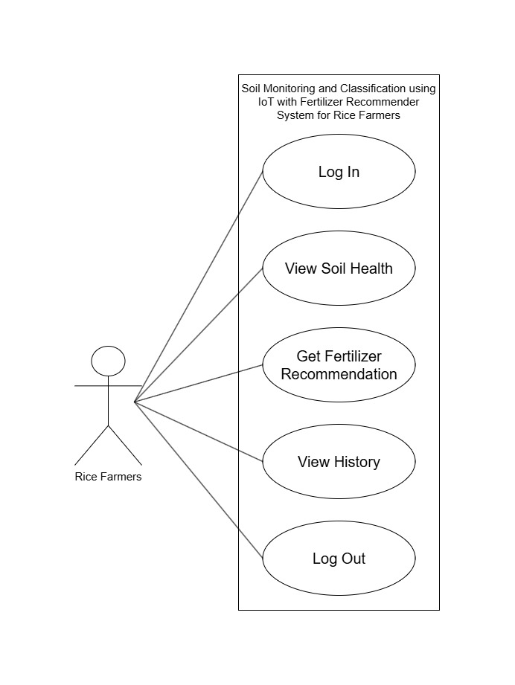
The rice farmer can log in to access the system. The system allows the farmer to use the soil monitoring and classification services of the platform. Through the web-based system, the farmer can view soil health, get fertilizer recommendations, and view their history of soil readings. The system also enables the farmer to securely log out of their account, providing a convenient way to manage and track their agricultural data online.

Figure 3. Use Case Diagram for Municipal Agriculture Officer
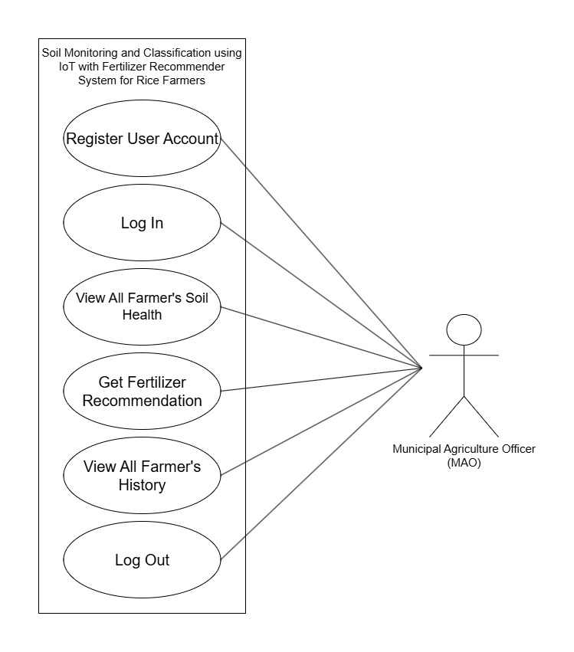
The Municipal Agriculture Officer (MAO) is able to register user accounts and log in to access the system. The system allows the MAO to oversee the soil monitoring and classification services of the platform for the entire municipality. Through the web-based system, the MAO can view all farmer's soil health, get fertilizer recommendations, and view all farmer's history of soil readings to monitor broader agricultural data. The system also enables the MAO to securely log out of their account, providing a convenient and centralized way to manage and track the community's agricultural records online.
Overall, the Use Case Diagrams demonstrate how the Soil Monitoring and Classification System using IoT with Fertilizer Recommender System manages farmer and administrative interactions to support precision agriculture in Unisan, Quezon. It illustrates how rice farmers initiate activities such as logging in, viewing real-time soil health from IoT sensors, requesting automated fertilizer recommendations, and tracking their historical soil data to improve crop yield. At the same time, the Municipal Agriculture Officer (MAO) registers user accounts and oversees the municipality's agricultural data by viewing all farmers' soil health records, generating fertilizer recommendations, and monitoring historical trends to support data-driven agricultural decision-making and sustainable farming practices.
Figure 3. Entity Relationship Diagram

Non-Functional Requirements.
The non-functional requirements for the Soil Monitoring and Classification System using IoT with Fertilizer Recommender System supply the rice farmers and the Municipal Agriculture Office (MAO) of Unisan with a dependable, safe, and high-performing environment. The system's quick reaction times and high availability, which enable users to view real-time soil data and generate fertilizer recommendations whenever needed, are designed to address the inefficiencies of manual estimation and traditional soil testing. In order to guarantee constant service delivery, the system is also built to be extremely dependable, keeping correct records of soil parameters (NPK, pH, moisture) and operating efficiently across a variety of devices and web browsers.
In terms of usability, the system offers an easy-to-use interface with readable text and clear navigation to streamline the user experience. Through a simplified process, farmers may simply register their accounts and handle operations, such as monitoring their specific farm's soil health or requesting automated fertilizer prescriptions. The platform provides administrators, specifically the MAO staff, with an easy-to-use interface to manage community-wide agricultural data, track soil trends in real-time, and view comprehensive historical reports. This emphasis on usability guarantees that farmers and agricultural officers may engage with the system's essential features without encountering any technological challenges, thereby enhancing data-driven decision-making and precision farming effectiveness.
The technology guarantees the security and privacy of user data in order to preserve the integrity of the municipality's agricultural operations. Farmers and MAO administrators must have authorized login credentials in order to access certain functional modules. The database structure is made to prevent unwanted access to and alteration of stored data, including sensitive account information, farm locations, and historical soil testing records.
To guarantee a simple and convenient user experience, the system is designed to deliver quick response times while processing sensor data, machine learning classifications, and fertilizer recommendation requests. The technology reduces operational delays and guarantees real-time data processing and updating by automating the manual soil analysis procedures. Because of this efficiency, the MAO staff can manage large amounts of agricultural data across the municipality and keep an eye on current soil health trends without sacrificing the speed or accuracy of the system.
The system demonstrates high reliability by consistently operating without errors and maintaining accurate records of soil readings, machine learning classifications, and generated recommendations. Through rigorous testing and quality assurance, specifically using ISO 25010 standards, the researchers ensure that the final system is stable and aligned with the actual operational needs of the local rice farmers. Furthermore, the system is designed to always be available, seamlessly receiving data from the deployed IoT sensors and providing a dependable platform for users to monitor their fields whenever needed.

Software Development Life Cycle
The Software Development Life Cycle (SDLC) is the organized process used to build the Soil Monitoring and Classification System. It guides the researchers from planning to implementation, ensuring the final product meets the needs of rice farmers and the Municipal Agriculture Office (MAO) for real-time soil tracking and accurate fertilizer advice. The project uses the Iterative Process because combining physical IoT hardware with machine learning requires constant testing and adjustments. Instead of a straight line, the system is built in repeating cycles of design, development, and testing. This allows the team to easily fix errors, improve sensor accuracy, and refine the platform based on real-world results throughout the development process.
The project is broken down into five main phases. First, in the Requirements Gathering phase, the team interviewed farmers and MAO staff to find out exactly what the system needs to track, resulting in the Software Requirements Specification document. Next, during System Design, the researchers planned the database, screen layouts, and hardware circuits. In the Implementation phase, the team actually built the project by writing the code, assembling the physical IoT sensors, and training the machine learning model.
Following implementation, the Testing and Quality Assurance phase heavily checked the system for errors. The sensors were calibrated, and users evaluated the platform based on ISO 25010 standards to ensure it was accurate and easy to use, producing formal test reports. Finally, in the Deployment and Maintenance phase, the finished system is set up for actual use in the fields of Unisan, complete with a plan for future updates. Overall, this flexible, cycle-based process ensures the final product is carefully tested, highly reliable, and ready to help the community improve their crop yield and use fertilizers more efficiently.

System Flow Diagram
The System Flow Diagram illustrates the overall flow of processes within the Soil Monitoring and Classification System using a flowchart. It provides a step-by-step representation of how data and control move through the platform, from the initial user login and IoT sensor readings to the final generated fertilizer recommendations.
Figure 4. Municipal Agriculture Officer Management Flow
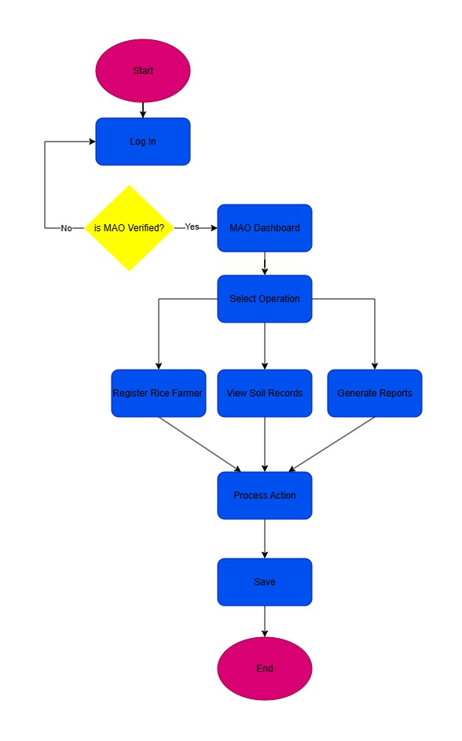
The MAO Management Flow outlines the standardized procedure for system monitoring and farmer registration. Using a decision node for user authentication, the sequence verifies the login credentials. Successful entries lead to the MAO Dashboard, while unsuccessful entries cause a loop back to the Log In screen. The agriculture officer must choose between Register Farmer, View Soil Records, or Generate Reports when prompted to select an operation inside this interface. Every choice moves the process into an action stage, where changes are carried out and completed with a save command, guaranteeing that all community agricultural records are appropriately recorded in the system database.
Figure 5. Rice Farmer’s Workflow

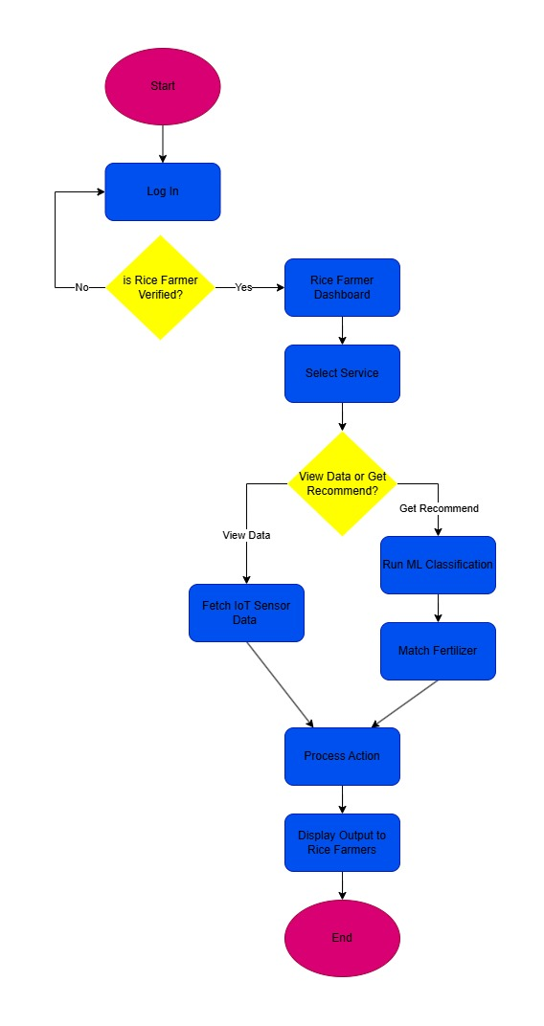

Data Flow Diagram
The Data Flow Diagram illustrates how data moves within the Development of Soil Monitoring and Classification using IoT with Fertilizer Recommender System by showing the flow of information between external entities, processes, and data stores. It provides a clear picture of how the system receives raw sensor inputs and user information, processes soil health data, and outputs fertilizer advice. This allows both farmers and agricultural officers to see how raw data is turned into helpful instructions for the farm.
The diagram identifies three external entities: the Rice Farmer, the Municipal Agriculture Officer (MAO), and the IoT Sensors. These entities represent individuals or hardware that provide data to the system or receive results from it. The Rice Farmer provides login details and requests for soil updates, while the MAO provides farmer details for registration and receives community-wide soil reports. Meanwhile, the IoT Sensors provide real-time readings of Nitrogen (N), Phosphorus (P), Potassium (K), pH, and moisture levels.
Figure 6. Data Flow Diagram
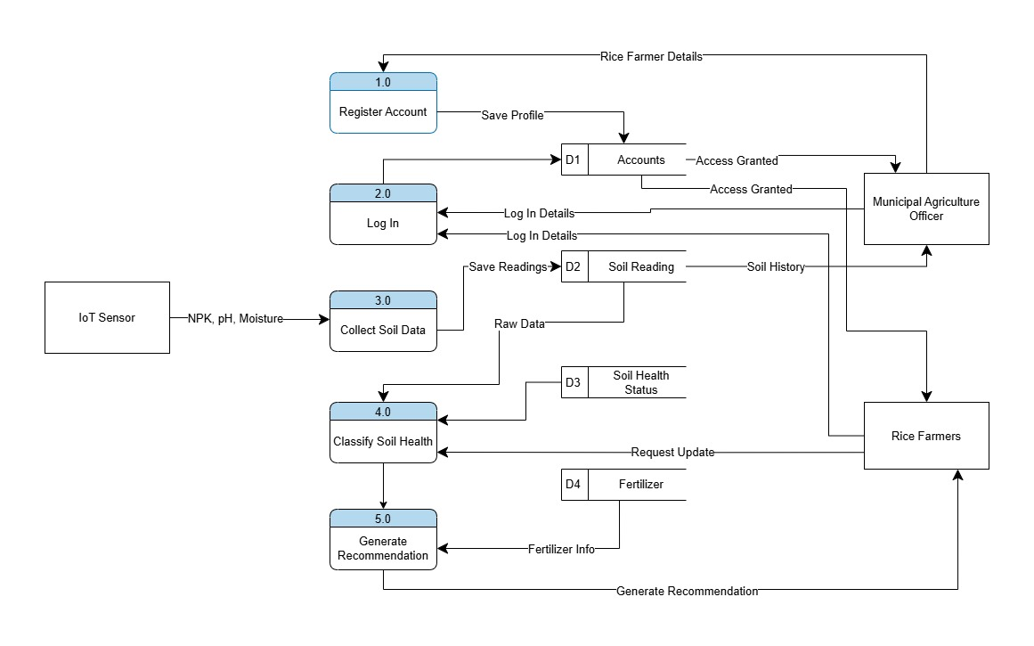
The diagram contains four key processes. In Register Account, the MAO inputs farmer details to create system profiles. Collect Soil Data receives and stores raw information from the IoT sensors. This data is passed to Classify Soil Health, where a machine learning model analyzes the readings to determine the soil's condition. Finally, Generate Recommendation uses this diagnosis to produce a specific fertilizer advice report for the farmer.
The system uses four data stores. The Accounts store secures user profiles and login details, while Soil Readings keeps a permanent record of all sensor measurements. Meanwhile, the Soil Health Status and Fertilizers stores provide the specific classification labels and nutrient details required by the system to recommend the correct fertilizer.
Overall, the Data Flow Diagram demonstrates how data is collected, processed, and stored across the platform. It highlights the seamless interaction between the farmers, the MAO, and the IoT hardware to manage soil health, ensuring that information flows efficiently to support data-driven farming and improve local crop yields.

Software Prototype
The Software Prototype of the Soil Monitoring and Classification using IoT with Fertilizer Recommender System shows the initial design of the platform. It gives users a clear picture of how the system will look and work, allowing everyone to see the layout and features before the actual coding begins.
The prototype includes seven main screens: the Login Screen, Farmer Dashboard, Farmer Soil Logs, MAO Municipality View, MAO Manage Sensor Screen, MAO All Logs Screen, and Logout Screen. Each screen serves a specific purpose and shows exactly what the Rice Farmers and Municipal Agriculture Office (MAO) staff will see and use.

The Login Screen lets users securely choose their role and enter their ID and password. For farmers, the Farmer Dashboard shows real-time soil health (NPK, pH, and moisture) and provides specific fertilizer advice, while the Soil Logs show their past readings. For the MAO, the Municipality View gives a quick overview of all farmers and active sensors in Unisan. The Manage Sensor Screen lets officers register and assign new IoT devices, and the All Logs Screen displays a complete list of community soil records. Finally, the Logout Screen confirms a safe exit from the platform.
The prototype demonstrates how users move through the system. After clicking "Login to Dashboard," users are taken directly to their main screen. A clear side menu helps them easily navigate to different pages, like "My Dashboard" for farmers or "Manage Sensor" for the MAO. Helpful buttons, like "Download Data," make it simple for users to save and interact with their information.
Overall, the Soil Monitoring and Classification using IoT with Fertilizer Recommender System prototype acts as a visual blueprint for the project. It clearly shows how the dashboards and records are organized and how both the farmers and the MAO will use them. This ensures the design meets all project goals and provides a strong foundation for building the final software.

Project Implementation Plan
The Project Implementation Plan of the Soil Monitoring and Classification using IoT with Fertilizer Recommender System outlines the structured approach for developing and deploying the system. It presents the phases, tasks, and timeline required to complete the project, serving as a guide for the researchers throughout the implementation process. The implementation plan is divided into five phases: Planning, System Analysis, System Design, Development and Testing, and Implementation. Each phase represents a distinct stage in the development lifecycle and contains a set of specific tasks that must be completed before progressing to the next phase.

Project Implementation Plan Gantt Chart
PROCESS | PROJECT IMPLEMENTATION PLAN
PROCESS | Nov | Dec | Jan | Feb | Mar | Apr | May | June | July
Planning
System Analysis
System Design
Development and Testing
Implementation

The project involves a dedicated development team, with members assigned to specific roles to ensure successful execution. The Project Lead is responsible for overseeing the overall project progress, coordinating hardware and software integration tasks, and ensuring the development plan is followed. The Technical Writer is responsible for drafting the formal project manuscript, maintaining the technical manual for the MAO, and creating the final project documentation. The System Developer handles the coding of the web dashboard, the database design, the assembly of the IoT sensor nodes, and the training of the machine learning classification model. The Quality Assurance Tester is responsible for conducting testing procedures, calibrating sensor accuracy against traditional soil tests, and documenting identified issues for correction based on ISO 25010 standards to ensure user requirements are met. Finally, the UI/UX Designer handles the design of the user interface to ensure the platform is intuitive for local rice farmers.
Overall, the Project Implementation Plan serves as a clear guide for completing the Soil Monitoring and Classification System for Unisan, Quezon. It breaks the project down into five main steps: Planning, System Analysis, System Design, Development and Testing, and Implementation. By listing the specific tasks, deadlines, and assigned team members, this plan ensures the researchers can work step-by-step to build, test, and launch the hardware and software on time to help the local farmers.

Chapter 4
RESULTS AND DISCUSSION
Write an opening section of a chapter that briefly presents the purpose, scope, and organization of the chapter, guiding the reader on what to expect in the succeeding sections.

- Subheading Number 1
Subheadings in Chapter 4 correspond directly to the findings for each research problem presented in Chapter 1. Each subheading reflects one specific subproblem stated in the Statement of the Problem and is arranged according to the same numerical sequence to ensure consistency and logical flow. These subheadings are formatted in block style, typed in single spacing, and presented in boldface to clearly distinguish them from the body text and to emphasize their importance in organizing the presentation of results.

- Subheading Number 2
Subheadings in Chapter 4 correspond directly to the findings for each research problem presented in Chapter 1. Each subheading reflects one specific subproblem stated in the Statement of the Problem and is arranged according to the same numerical sequence to ensure consistency and logical flow. These subheadings are formatted in block style, typed in single spacing, and presented in boldface to clearly distinguish them from the body text and to emphasize their importance in organizing the presentation of results.

- Subheading Number 3
Subheadings in Chapter 4 correspond directly to the findings for each research problem presented in Chapter 1. Each subheading reflects one specific subproblem stated in the Statement of the Problem and is arranged according to the same numerical sequence to ensure consistency and logical flow. These subheadings are formatted in block style, typed in single spacing, and presented in boldface to clearly distinguish them from the body text and to emphasize their importance in organizing the presentation of results.

- Subheading Number 4
Subheadings in Chapter 4 correspond directly to the findings for each research problem presented in Chapter 1. Each subheading reflects one specific subproblem stated in the Statement of the Problem and is arranged according to the same numerical sequence to ensure consistency and logical flow. These subheadings are formatted in block style, typed in single spacing, and presented in boldface to clearly distinguish them from the body text and to emphasize their importance in organizing the presentation of results.

Chapter 5
SUMMARY OF FINDINGS, CONCLUSIONS, AND RECOMMENDATIONS
Write an opening section of a chapter that briefly presents the purpose, scope, and organization of the chapter, guiding the reader on what to expect in the succeeding sections.

Summary of Findings
Summary of Findings is the section in Chapter 5 of a research study that presents a concise and clear recap of the major results of the study in Chapter 4, based directly on the data analysis, without interpretation, discussion, or recommendations.

Conclusions
Conclusions are the section in Chapter 5 of a research study where the researcher presents general statements or judgments derived from the study’s findings, indicating what can be inferred from the results in relation to the research objectives or questions.

Recommendations
Recommendations are the section in Chapter 5 of a research study that present practical suggestions or proposed actions based on the study’s conclusions, intended to address identified issues, improve practices, or guide future research.

.

References
Abana, E., & Sy, B. (2022). ISO/IEC 25010 based evaluation of rice seed analyzer: a machine vision application using image processing technique. Indonesian Journal of Electrical Engineering and Computer Science, 28(2), 994. https://doi.org/10.11591/ijeecs.v28.i2.pp994-1001
Adhikary, R., Choudhury, S. J., & Shankar, T. (2024). Real-Time Soil Nutrient Monitoring Using NPK Sensors: Enhancing Precision Agriculture. International Journal of Experimental Research and Review, 45(Spl Vol), 197–202. https://doi.org/10.52756/ijerr.2024.v45spl.015
Akhilesh, S., Abburi, B. T., Somya, P., Sai Krishna, R. M., & Srihari, T. (2025). Fertilizer Recommendation for Agriculture using Machine Learning. International Journal of Multidisciplinary Research and Growth Evaluation., 6(2), 756–760. https://doi.org/10.54660/.IJMRGE.2025.6.2.756-760
Allen Paul, E., & Ruth Ann, S. (2021). Development and Assessment of Online Platform for Crop Production with Decision Support System. The QUEST: Journal of Multidisciplinary Research and Development, 1(1). https://doi.org/10.60008/thequest.v1i1.12
Andrea Mei Summer Tadeo Castañeda, Louise Llaine Verallo De Armas, Raymund Dioses, Ariel Antwaun Rolando Sison, Diony Abando, & Criselle Centeno. (2024). SustAIn: An AI integrated system designed to evaluate the health of house plants. World Journal of Advanced Research and Reviews, 24(2), 2362–2368. https://doi.org/10.30574/wjarr.2024.24.2.3522
Bulawit, G. D., Palaoag, T. D., & Bulawit Jr., B. E. (2023). Android-based Corn Disease Automated Recognition Tool Using Convolutional Neural Network. International Journal of Experimental Research and Review, 30, 236–246. https://doi.org/10.52756/ijerr.2023.v30.021
Davis, F. D. (1989). Perceived Usefulness, Perceived Ease of Use, and User Acceptance of Information Technology. MIS Quarterly, 13(3), 319–340. https://doi.org/10.2307/249008
Dela Cruz, B., Ramos, R., Carambas, G. M., Peronce, I. P., & Perreras, J. (2025). Digging Deeper: Soil Quality Monitoring System for Alaminos City Farmers. International Journal of Research and Innovation in Social Science, IX(II), 1542–1547. https://doi.org/10.47772/IJRISS.2025.9020126
G. Kalaiselvi, M. Nisha, M. Rudhra, & V. Shrivaishnavi. (2025). Generative AI based Fertilizer and Pesticide Recommendation System for Farmers. International Journal of Science and Research Archive, 15(2), 1536–1546. https://doi.org/10.30574/ijsra.2025.15.2.1498
G. Vergara, D. I., G. Micabalo, K., J. Calimlim, B., P. Cañete, O., & R. Flores, H. (2024). Sustaining Rice Farming: Challenges and Solutions for Agribusiness in Barangay Tagum Norte, Trinidad, Bohol. International Multidisciplinary Research Journal, 6(4). https://doi.org/10.54476/ioer-imrj/786094
Goloran, J. B. (2025, October 6). Out of poverty: Helping Filipino farmers uplift their farm productivity. Agriculture Monthly.
Hartono, R., Nanang, M. Y., & Purnomo, A. (2024). Design and Implementation of an IoT System for Soil Nutrient Monitoring with MQTT Communication and Temporary Data Storage. Ecological Engineering & Environmental Technology, 25(12), 333–345. https://doi.org/10.12912/27197050/195115
Hossain, Md. D., Kashem, M. A., Sadeq, M. J., Mustary, S., & Ferdus, M. Z. (2024). IoT Enabled Soil Fertilizer Monitoring and Recommendation System in the Context of Bangladeshi Agriculture. 2024 IEEE International Conference on Power, Electrical, Electronics and Industrial Applications (PEEIACON), 416–421. https://doi.org/10.1109/PEEIACON63629.2024.10800551
Kai, T., Tsuchiya, M. C. L., Garcia, J. N. M., & Medina, S. M. (2025). Assessing Soil Fertility and Challenges in Organic Vegetable Farms: A Case Study in the Philippines. Journal of Agricultural Chemistry and Environment, 14(01), 102–120. https://doi.org/10.4236/jacen.2025.141007
Kethineni, K., Mekala, S. H., Kodali, M., Kota, V. V., & Jampani, J. P. (2024). A Web-Based Agriculture Recommendation System using Deep Learning for Crops, Fertilizers, and Pesticides. 2024 International Conference on Computational Intelligence for Green and Sustainable Technologies (ICCIGST), 1–6. https://doi.org/10.1109/ICCIGST60741.2024.10717535
Latha, P., & Kumaresan, P. (2025). Deep Learning for Soil Nutrient Prediction and Strategic Crop Recommendations: An Analytic Perspective. Nature Environment and Pollution Technology, 24(1), B4205. https://doi.org/10.46488/NEPT.2025.v24i01.B4205
Louiella Samaniego, A., & Gallego, M. (2024). Farm Soil Testing Techniques, Soil Health, and Potential Impact of Artificial Intelligence as Factors of Small-Scale Farming Soil Management. E3S Web of Conferences, 595, 03001. https://doi.org/10.1051/e3sconf/202459503001
Mishra, A. K., Maurya, P. K., & Sharma, S. (2024). Impact of different farming scenarios on key soil sustainability indicators driving soil carbon and system productivity of rice-based cropping systems. Frontiers in Plant Science, 15. https://doi.org/10.3389/fpls.2024.1408515
Nakao, A., Masai, F., Timbas, N., Medina, S., Abe, S. S., Tanaka, S., & Yanai, J. (2021). Changes in lowland paddy soil fertility in the Philippines after 50 years of the Green Revolution. Soil Science and Plant Nutrition, 67(4), 446–459. https://doi.org/10.1080/00380768.2021.1947118
Ponkumar, D. D. N., Kumar, K. P. K. H., Ramesh, S., Kumar, J. A., Nallasivan, G., & Jayachandra, A. (2024). Machine Learning Algorithm for Predicting Soil Classification using Smart Agriculture. 2024 3rd International Conference on Sentiment Analysis and Deep Learning (ICSADL), 196–202. https://doi.org/10.1109/ICSADL61749.2024.00038
Richey, R. C., & Klein, J. D. (2014). Design and Development Research. In Handbook of Research on Educational Communications and Technology (pp. 141–150). Springer New York. https://doi.org/10.1007/978-1-4614-3185-5_12
Robert, P. C. (2002). Precision agriculture: a challenge for crop nutrition management. Plant and Soil, 247(1), 143–149. https://doi.org/10.1023/A:1021171514148
Sinclair, R., Nodi, S., & Kabir, M. A. (2024). Evaluating mobile applications for estimating soil properties: Quality of current apps, limitations and future directions. Computers and Electronics in Agriculture, 216, 108527. https://doi.org/10.1016/j.compag.2023.108527
Sulaeman, Y., Sutanto, E., Kasno, A., Sunandar, N., & Purwaningrahayu, R. D. (2024). Developing and Testing a Portable Soil Nutrient Detector in Irrigated and Rainfed Paddy Soils from Java, Indonesia. Computers, 13(8), 209. https://doi.org/10.3390/computers13080209
Urera, F. L., & Balahadia, F. F. (2019). ICTeachMUPO: An Evaluation of Information E-Learning Module System for Faculty and Students An evaluation of information e-learning module system for faculty and students. International Journal of Computing Sciences Research, 3(1), 163–188. https://doi.org/10.25147/ijcsr.2017.001.1.31
Venkateswara, S. M., & Padmanaban, J. (2025). Interpretable deep learning models for independent fertilizer and crop recommendation. Scientific Reports, 15(1), 41721. https://doi.org/10.1038/s41598-025-26910-4
Vu Ngoc, K., & Giang Trung, M. D. (2025). Statistical assessment of agricultural fertilizer impacts on water quality and environmental sustainability. Heritage and Sustainable Development, 7(1), 401–414. https://doi.org/10.37868/hsd.v7i1.1217
Wacas, R. (2023). SMART GREENHOUSE: AN IOT-BASED MONITORING AND CONTROL SYSTEM WITH PREDICTIVE ANALYTICS (Vol. 8, Issue 2). https://www.thelight-explorer.com/

APPENDICES

Appendix 1
PERMIT TO CONDUCT STUDY
Date

Hon. JOSE MUMAR P. VELUZ
Municipal Mayor
Municipality of Unisan
Brgy. Dimatagpuan, Unisan, Quezon

Dear Mayor Veluz:

We are the 4th Year students of Bachelor of Science in Information Technology were tasked to develop a computer system as part of the requirements in Capstone Project course. The system aims state here the main purpose of your system.

In line with this, we are requesting your permission to allow us to gather pertinent data with the state here your target group and reason why they are chosen. We assure you that the information gathered will be treated carefully and will be used only for academic purposes.

Thank you for your favorable response and God bless!

Respectfully yours,

MARK JOSEPH C. DELA CRUZ | MARK JOSEPH C. DELA CRUZ
Student Researcher | Student Researcher
MARK JOSEPH C. DELA CRUZ | MARK JOSEPH C. DELA CRUZ
Student Researcher | Student Researcher
MARK JOSEPH C. DELA CRUZ
Student Researcher

Noted by:

NAME OF ADVISER | Dr. JONATHAN A. MARQUEZ
Capstone Project Adviser | Head of Academic Programs

Approved by:

Dr. EDWIN G. MALABUYOC
Director

Appendix 2
INSTRUMENTS
Put your content here….

Appendix 3
CERTIFICE OF ORIGINALITY
CERTIFICATION OF ORIGINALITY CHECK
This is to certify that the undersigned has been the one responsible for the similarity testing using TURNITIN of the capstone project entitled, “Write your Title Here” authored by FirstName M.I. LastName, FirstName M.I. LastName, FirstName M.I. LastName, FirstName M.I. LastName, and FirstName M.I. LastName.
Furthermore, the combined total of all matches, including overlapping sources, for each database got ____ overall similarity, with a Similarity Report ID: __________.

Certified by:
_________________________
Head of Admission and Registration

Appendix 4
CERTIFICATE OF EDITING

CERTIFICATION
January 6, 2026
To the University Research Committee:
This is to certify that the capstone project entitled Write your Capstone Title Here prepared by Last Name, First Name M.I., Last Name, First Name M.I., Last Name, First Name M.I., Last Name, First Name M.I., and Last Name, First Name M.I. was examined and proofread by the undersigned person in accordance with the basic mechanics and accepted sentence structures in English.

Dr. PABLO S. GOMEZ, LPT, MEM
Instructor, Polytechnic University of the Philippines
Unisan, Quezon Campus
Language Editor

Appendix 5
ACCEPTANCE LETTER OF ADVISER
Date
Mr. JUAN S. DELA CRUZ, MIT
Instructor
Polytechnic University of the Philippines
Unisan, Quezon Campus

Dear Mr. DELA CRUZ:

We are the students under the program of Bachelor of Science in Information Technology currently taking up our subject, Capstone Project. As part of our requirement, we are obliged to have a research adviser. In line with this, we respectfully propose the research topic we intend to pursue for our capstone project: insert capstone topic here.
Given your extensive background in the field of research and information technology, we would like to seek your guidance in crafting our paper and be our research adviser.

Your acceptance and positive response regarding this matter is highly appreciated. Thank you very much and God Bless.

Sincerely yours,

MARK JOSEPH C. DELA CRUZ | MARK JOSEPH C. DELA CRUZ
Student Researcher | Student Researcher
MARK JOSEPH C. DELA CRUZ | MARK JOSEPH C. DELA CRUZ
Student Researcher | Student Researcher
MARK JOSEPH C. DELA CRUZ | MARK JOSEPH C. DELA CRUZ
Student Researcher | Student Researcher
MARK JOSEPH C. DELA CRUZ | MARK JOSEPH C. DELA CRUZ
Student Researcher | Student Researcher

Accepted and Approved:

Mr. JUAN S. DELA CRUZ, MIT
Instructor
Date Signed: ___________________

Appendix 6
USER MANUAL
Put your content here….

Appendix 7
BIOGRAPHICAL STATEMENT
Put your 2x2 ID Picture Here
Juan Miguel Dela Cruz is a graduating student of Bachelor of Science in Psychology at the Polytechnic University of the Philippines. He completed his undergraduate coursework with a focus on developmental and educational psychology. His academic interests include student mental health, learning motivation, and psychological well-being among Filipino youth. His undergraduate research examines factors affecting academic stress among senior high school students. He plans to pursue graduate studies in psychology and engage in research related to mental health advocacy and education. (Note: Minimum of 100 and maximum of 150 words only)
Put your 2x2 ID Picture Here
Maria Angela Dela Cruz is a graduating student of the Bachelor of Science in Psychology at the Polytechnic University of the Philippines. She completed her undergraduate studies with an emphasis on developmental and social psychology. Her academic interests include mental health awareness, emotional resilience, and psychological well-being among adolescents. Her undergraduate research focuses on stress management and coping mechanisms of senior high school students. She plans to pursue graduate studies in psychology and contribute to community-based mental health programs. (Note: Minimum of 100 words and Maximum of 150 words only)
Put your 2x2 ID Picture Here
Angela Marie Santos is a graduating student of the Bachelor of Science in Psychology at the Polytechnic University of the Philippines. Her academic training centers on counseling psychology and human behavior, with particular interest in emotional intelligence and student well-being. Her undergraduate thesis explores the relationship between self-esteem and academic performance among college students. She intends to pursue professional training and graduate studies in psychology, with the goal of contributing to mental health education and support programs. (Note: Minimum of 100 and maximum of 150 words only)
Put your 2x2 ID Picture Here
Mark Anthony Reyes is a graduating student of the Bachelor of Science in Psychology at the Polytechnic University of the Philippines. His undergraduate training emphasizes cognitive and social psychology, with particular interest in decision-making and behavioral patterns among young adults. His undergraduate thesis examines the influence of social media use on attention and academic engagement of college students. He plans to pursue graduate studies in psychology and engage in research and advocacy focused on youth mental health and well-being. (Note: Minimum of 100 and maximum of 150 words only)
Put your 2x2 ID Picture Here
Maria Angela Dela Cruz is a graduating student of the Bachelor of Science in Psychology at the Polytechnic University of the Philippines. She completed her undergraduate studies with an emphasis on developmental and social psychology. Her academic interests include mental health awareness, emotional resilience, and psychological well-being among adolescents. Her undergraduate research focuses on stress management and coping mechanisms of senior high school students. She plans to pursue graduate studies in psychology and contribute to community-based mental health programs. (Note: Minimum of 100 and maximum of 150 words only)

